

IHE Work Item Proposal (Short)

# Proposed Work Item: Diagnostic Study Request - Workflow Definition

Proposal Editor: Vincent van Pelt

Work item Editor: Robert Breas

Date: October 5th, 2012

Version: 0.1

Domain: Patient Care Coordination

# The Problem

In the diagnostic process, there are many types of diagnostic studies that a physician can request (see Appendix A). The requesting of these types of studies, and the results of these studies (images, reports) is not a standardized process. For some diagnostic studies, HL7 ORU- and ORM messaging are used, but there is no standardized method that permits the tracking of the status of the process, or the linking of the request to the documents that are produced as a result of the diagnostic study. The DSR-WD describes the workflow of the requesting (and consequent workflow) of any type of diagnostic study. This Workflow Definition is a template that describes the different phases in the process of a diagnostic study workflow, and allows the monitoring of the status of the requested diagnostic study.

Currently, there is no standardized method for the monitoring of the diagnostic study requesting. The DSR-WD Patient Care Coordination profile would allow a generic approach towards the requesting, monitoring and archiving of the workflow of any diagnostic study.

# Key Use Case

Dr. Fripp, a cardiologist, receives a patient with severe chest pain. After anamnesis and physical examination, he decides to request the following diagnostic studies: an angiogram, an ECG, some lab-studies, and an X-thorax. These requests are sent to different departments in the hospital, and to locations outside the hospital. In the current situation, there is no generic way to see what the status of these different requests is. The DSR-Workflow Definition documents inform all persons involved about the status of the different diagnostic study requests, and link the process to the documents and images that are produced. This allows a more standardized approach towards the managing of these different workflows.

# Standards & Systems

The Diagnostic Study Request - Workflow Definition is based upon the ITI-XDW Profile.

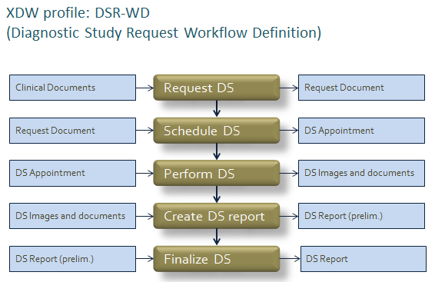

# Discussion

IHE is the perfect platform for a problem that involves many different processes and participants. The solution is content-agnostic and vendor-neutral. The DSR-WD could become a basic building block for the workflow management of diagnostic studies.

# Appendix A - overview of diagnostic studies

* Audiometry
  + Audiogram
  + Tympanogram
* Echography / TDI (Tissue Doppler Imaging) / Echotherapie
* Elektrography
  + ECG (electrocardiogram)
  + EEG (electro-encephalogram)
  + EMG (electro-myogram)
  + ENG (electronystagmogram)
* Endoscopy
  + Bronchoscopy
  + Colonoscopy
  + Colposcopy
  + Cystoscopyh
  + ERCP (endoscopic retrograde cholangiopancreatography)
  + Gastroscopy
  + Hysteroscopy
  + Laparoscopy
  + Mediastinoscopy
  + Sigmoidoscopy
* Medical photography
  + Fluorescein angiography (for diabetic retinopathy)
  + Before-after photos (dermatology, surgery, decubitus)
  + Videos (revalidation, movement studies, behavior)
  + Microscopic images (cell structures)
* Function studies
  + Longfunction tests
  + Ergometry, Holter tests
  + Neurological function tests
  + UDO (urodynamic studies), flow measurements
  + DAS28 (disease activity score, reumatology)
* Laboratory studies, clinical chemistry
* Laserdiagnostics
  + retina-tomografie
* Magnetic Resonance Imaging (MRI)
  + Body scan
  + Cholangiopancreatography
  + Brainscan
  + Vertebra-scan
* Pathological studies
  + Punction
  + Biopsy
* Radiological studies
  + Bone scan, Bone density test - osteoporosis
  + Radiology studies (X-thorax, X-mamma, et cetera)
  + Radiodiagnostics (PET, scintigrafie, SPECT)
    - CAG (coronair angiogram)
    - Hysterosalpingogram
  + CT (Computed Tomography)
    - Angiogram
    - Cystourethrogram
    - Intravenous pyelogram
* Tonometry
  + IOP (intraocular pressure)
* Other diagnostic studies
  + CTG (Cardiotocografie)
  + Electrophysiological studies
  + Snellen test